

**Excel Assignment - 6**

1. What are the various elements of the Excel interface? Describe how they're used.

Ans: There are multiple elements of Excel interface like Quick Access Toolbar, Title Bar, Menu Bar, Formula Bar, Dialog box.

Uses are to manage and easily understandable by step by step like Formula bar used to see the formula , toolbar shows the all tools and Title Bar shows all the title of the function etc.

1. Write down the various applications of Excel in the industry

Ans: Excel are used Widely in many industries. Like Financial Analysis, Sales and Marketing, project management, For entry purpose etc.

1. On the ribbon, make a new tab. Add some different groups, insert commands in the groups and name them according to their commands added. Copy and paste the screenshot of the steps you followed.

Ans: Go to File> 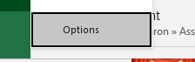 then > 

Then> Add New tab and rename 

Then add as per requirement 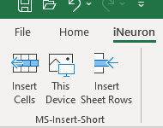

1. Make a list of different shortcut keys that are only connected to formatting with their functions.

Ans: Ctrl + 1 For Format cells, Ctrl + B for text in Bold, Ctrl+ I for underline,

ALT D+F=F for Filter, ALT H+B+A for all Border , ALT W+F for Freeze/Unfreeze, ALT A+ M for duplicate remove, Ctrl+Alt+V for paste values ,ALT O+ C+R these are widely used in excel.

1. What distinguishes Excel from other analytical tools?

Ans: Excel has a user friendly interface, easy to use and flexible to work with wide range of features, Excel has various functions and formula that allow us to help in calcullations, we can use it without need of internet etc.

1. Create a table and add a custom header and footer to your table.

Ans: Header

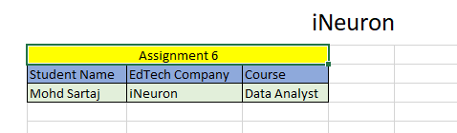

Footer





